**Homework 6: Playing With Spheres**

**Quantum Mechanics II: PHYS 511**

**Gabriel M Steward**

**February 2022**

**Texts Referenced:**

**Modern Quantum Mechanics, Sakurai and Napolitano**

**Introduction to Quantum Mechanics, Griffiths and Schroeter**

**(Further references at the end)**

**Problem 1**

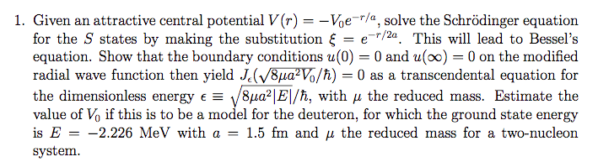

The Schrodinger equation for a spherical symmetric potential reads



Y is a spherical harmonic, while R is from the radial equation.

We are told to find the S states, which means s-orbitals, that is, the spherically symmetric ones where l=0 and thus m must equal 0 as well since m ranges along [-l,l]. This means Y is Y00 which is known to be 1/√(4π), essentially just defining the lack of angular dependence.

Now we seek R. The radial equation reads:



We know l and V in this case, so we can substitute those values in.



Lots of annoying r terms here, let’s convert this to the modified radial wave equation.



We are asked to make a specific substitution, . This… will result in some very awkward substitutions, but with the chain rule we can alter the derivative. Referring to [4] to adjust the second derivative. The result becomes:



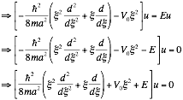

Now that the substitution has been performed, we need to get this in a Bessel form. How exactly we do that is an excellent question, as there’s no point in making a k-substitution of any sort here.

Much fumbling around to no avail was cut out here. Apparently the next step was as simple as dividing by ξ twice. (Originally we had substituted the second derivative wrong).

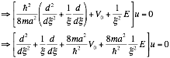

And this is in Bessel form! *Finally.* However, the constants are still a little odd. We need to somehow make the V0 term equivalent to “1” without interfering with any of the derivatives. Scaling ξ by a constant may allow this to work: make a specific constant pop out and then divide.

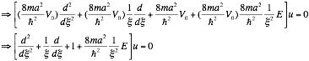

Now this is true Bessel form. Referring to [1] rather than the slides for the general Bessel formulation, we find that our answer is Jn where



Don’t have time to justify the absolute value signs right now but we know that’s what they have to be. We can justify the m->µ though. The math is the same for both m and µ (the reduced mass) but m makes the assumption that one part doesn’t move, while µ just focuses on the center of mass. Using m is somewhat unrealistic, but equivalent to µ mathematically.

Since this is u, and u=Rr the answer for R becomes:



And so the *entire* answer is

|  |
| --- |
|  |

Ah, but what is our Bessel a function of? Well, in theory, ξ, but we scaled ξ by a constant, so what we really have is:

|  |
| --- |
|  |

Now our boundary conditions are u(0)->0 and u(∞)->0.

The second boundary condition is trivially true, we have a 1/r wavefunction.

The first boundary condition is the trick, since 1/r blows up, so we need our J function to be zero when r is zero. When r is zero, though, our J function is…



Which is exactly what we sought to show! Yes! Hah! *Finally!*

Unfortunately it is now 9:07 and we have a class at 9:30 so there will be no estimation… It’s really a shame and quite unacceptable to leave work unfinished like this, we can only hope partial credit will be given. The method for estimation would most likely involve using Wolfram Alpha [2] to get an “exact” J value by plugging in the values of all the constants, but that would be time consuming.

**Problem 2**

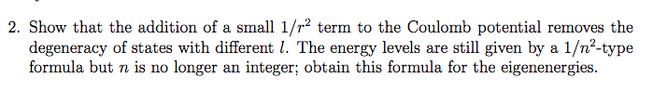

To begin, declare the coulomb potential with the added 1/r2 term.



Where Smol is an arbitrary constant intended to remind us that the added term is “small.” What exactly this means remains to be seen, but at the outset it is just intended to be a much smaller contributor to V than the first term in most situations. Unlike in **Problem 1** though, our solutions require that we take into account arbitrary l values. We still use the modified radial wave equation, though. This time with the ul subscript as we do not know l.

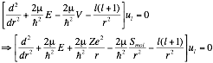

We will follow the standard steps for computing the Coulomb Potential until they no longer make sense to perform. Right now, defining ξ=r/a0 is sensible.



Using the standard definitions for a0 and ε

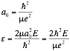

we arrive at:





We note that the Smol term is just a constant added to the angular momentum part. Since we are working out bound states, ε=-|ε|

We now define a new function wl from ul so we now can say:

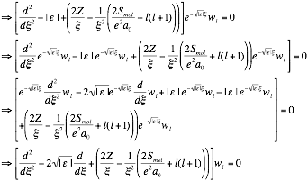

This is a very similar form to the standard, so we continue as before: power series solution. Referring to [3] somewhat to make sure we remember how to do a power series solution. Starting with the form:



And the derivatives



Usually in power series solutions the index shrinks as derivatives are taken—not here, since it is not known how close l is to zero. Now substitute and adjust. For simplicity and clarity, we absorbed constants into Smol since it’s an arbitrary constant anyway:

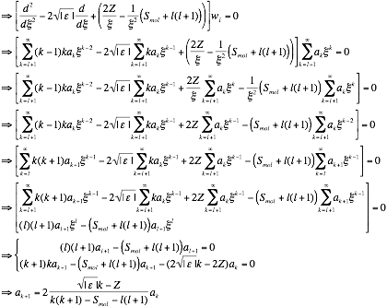

Well this is very curious: if Smol weren’t there, the initial conditions would become indeterminate, which is why al+1 has to be determined by normalization under regular circumstances. However with Smol there, we have a case where al+1 must either equal zero no matter how small Smol may be, which has a rather unpleasant cascade effect.

HOWEVER, we need to realize that the series we have is only valid for k≥l+1. We know l itself can take negative values and the like, so it becomes evident that our equation up there that says al+1 must equal zero isn’t accurate: there’s most definitely an al in the full formulation of the solution.

If we take Z=1, the iterative result is essentially identical to the normal Coulomb energy term, except for the additional Smol term. Admittedly, this is a recursive relation for the coefficients so it doesn’t help us with an exact solution, but we don’t need one at the moment: we just need to show that different l values no longer produce the same energy state.

When we start making assumptions for large k, the Smol term completely vanishes, meaning the same implications for the standard Coulomb potential for large k still apply: such as



However, we know that ul has to go to zero at infinity rather than increasing without bound, so the recursion must terminate at some k=n. This n is determined entirely by the numerator of the expression, which is exactly the same as in the Coulomb potential. It allows us to solve for E. Which implies that



Which can’t be the case, we need it to depend on l. And yet, where could the mistake have been? Smol was never abstracted away; it just ended up in the denominator where it had no effect.

At this point (and many points before) we went searching for literature, specifically on spin-orbit splitting in energy levels. Nothing useful came up, but the answer is supposed to be 1/n2 according to the problem statement, but the literature suggested the effect was a 1/n3. Maybe this means our original assumption that this was about spin orbit splitting was incorrect?

Again, really is unacceptable to leave a problem finished like this, we sincerely regret not being able to follow this homework to its conclusion.

REFERENCES:

[1] Bessel Function Statements

<https://mathworld.wolfram.com/BesselFunctionoftheFirstKind.html>

[2] Wolfram Alpha Calculator <https://www.wolframalpha.com/input?i=Jn%28z%29>

[3] A review on series solutions for differential equations.

<https://tutorial.math.lamar.edu/classes/de/seriessolutions.aspx>

[4] Second derivative chain rule

<https://math.stackexchange.com/questions/1313764/changing-variable-in-a-second-derivative>

I know this isn’t a great source but I’m pressed for time.